**Request for Quotation**

**for Providing, fixing and installation of 2-track, UPVC sliding windows for PPD, MoAF**

Date: 15th April, 2022

**Invitation for Quotation (IFQ) through Shopping (National)**

Project title: **YERE Project, JSDF**

Source of Funding: **World Bank**

Contract Ref: DS/PRO/MoAF/06/2021-2022/ **205**

To:

***All Interested Bidders having valid Trade license / CDB license to carry out installation works.***

Dear Sir/Madam,

1. You are invited to submit your priced bid for the supply of the following items:

**Providing, fixing and installation of 2-track, UPVC sliding windows**

[*Information on technical specifications and required quantities are attached ]*

1. The bidder(s) must quote for all the items under this invitation. Priced quotations will be evaluated for all the items together as a single package and contract awarded to the firm offering the lowest evaluated total cost. Price quoted for after sales services/maintenance shall form a part of the contract but will not be added to the total contract amount.
2. The bidder(s) shall submit one original of the priced quotation with the Form of Bid, clearly marked ORIGINAL. In addition, the bidder(s) should also submit one copy marked as COPY. The quotation including all documents in the attached format should be sealed in an envelope and addressed to and delivered at the following address:

Your quotation in the required format should be addressed and submitted to:

**The Procurement Officer,**

**Procurement Section, MoAF**

**Tashichhodzong, Thimphu**

**Contact: 322572**

1. The deadline for receipt of your quotation(s) by the purchaser at the indicated address isbefore **11:00 AM of 22nd April, 2022** and it will be opened on the same day at **11:30 AM**
2. Bids shall be accompanied by a bid security **of Nu. 4000.00** in favour of Offtg. Director, DS, MoAF in the form of cash warrant, demand draft or unconditional Bank Guarantee valid till **October, 2022 ( 6 months)**Any bid not accompanied by bid security shall be treated as non-responsive.
3. Quotation by fax or by electronic means **are not** acceptable.
4. The quotation should be submitted as per the following instructions and in accordance with the attached Contract. The attached Terms and Conditions of Supply is an integral part of the Contract.
5. PRICE: all prices shall be quoted in Ngultrum. The quoted price shall be inclusive of all related costs including taxes, duties and other levies to the final place of delivery. The final place of delivery is **PPD, MoAF, Thimphu.**
6. EVALUATION OF QUOTATION: offers determined to be substantially responsive to the technical specifications will be evaluated by comparison of their quoted prices. In evaluating the quotations, the purchaser will determine for each quotation the evaluated price by adjusting the priced quotation by making any correction for any arithmetical errors as follows;

(i) where there is a discrepancy between amounts in figures and in words, the amount in words will govern;

(ii) where there is discrepancy between the unit rate and the line item total resulting from multiplying the unit rate by the quantity, the unit rate as quoted shall govern unless in the opinion of the Employer there is an obviously gross misplacement of the decimal point in the unit rate, in which case the line item total as quoted shall govern, and the unit rate shall be corrected.

(iii) if the supplier refuses to accept the correction, the quotation will be rejected and the bid security forfeited.

1. AWARD OF PURCHASE ORDER: the award will be made to the bidder who has offered the lowest evaluated price that meets the specifications. The successful bidder will sign a contract as per attached form of contract and terms and conditions of supply.
2. VALIDITY OF THE OFFERS: the quotation(s) shall be valid for a period of 60 days from the deadline for receipt of quotation(s).
3. Further information can be obtained from:

**The Procurement Officer,**

**Procurement Section, MoAF**

**Tashichhodzong, Thimphu**

**Contact: 322572**

1. The quotation(s) will be opened in the presence of bidders or their representatives who choose to attend at **Office of the Procurement Section on 22nd April, 2022 at 11:30 AM**
2. The Purchaser is not bound to accept the lowest bid and reserves the right to accept or reject any or all the bids without assigning any reason whatsoever.
3. The Purchaser will notify the winning bidder of the award of contract prior to the expiry of quotation validity period. The terms of the accepted offer shall be incorporated in the supply order (sample form attached).
4. The Goods supplied should have a minimum Warranty/guarantee of 28 months from the date of delivery or 24 months from the date of acceptance, whichever is later.
5. The full Contract Price shall be paid within thirty (30) days once the works are fully completed.

**Schedule of Items and Priced Quotation (Bid form)** *[To be filled in by Bidders]*

|  |  |  |  |  |  |  |
| --- | --- | --- | --- | --- | --- | --- |
| Sl | Item Description | Unit | Qty | Make/Model | Unit  Rate  (Nu.) | Total Amount  (Nu.) |
| 1 | Providing, fixing and installation of 2-track , UPVC sliding windows including 5mm clear glass firrings  ***(Check Technical specifications of the works)*** |  |  |  |  |  |
|  | **Total Amount for Supply of Goods to Purchaser**  **(Including taxes and all related cost)s**  **Goods to be supplied to *PPD, MoAF, THIMPHU*** | | | | |  |

|  |  |
| --- | --- |
| Total Amount in  Nu. (in words) |  |
| Delivery period | ***30 days*** |
| Warranty Provided | *………….. Months from date of supply or commissioning of the Goods.* |

*[The purchaser shall provide in the table above an indicative list of after sales services/maintenance required which shall not be added to total contract amount]*

|  |  |
| --- | --- |
| Signature of Supplier | Supplier’s Official Stamp |
| Name of Supplier |
| Date |

**Technical Specification of the Goods Required**

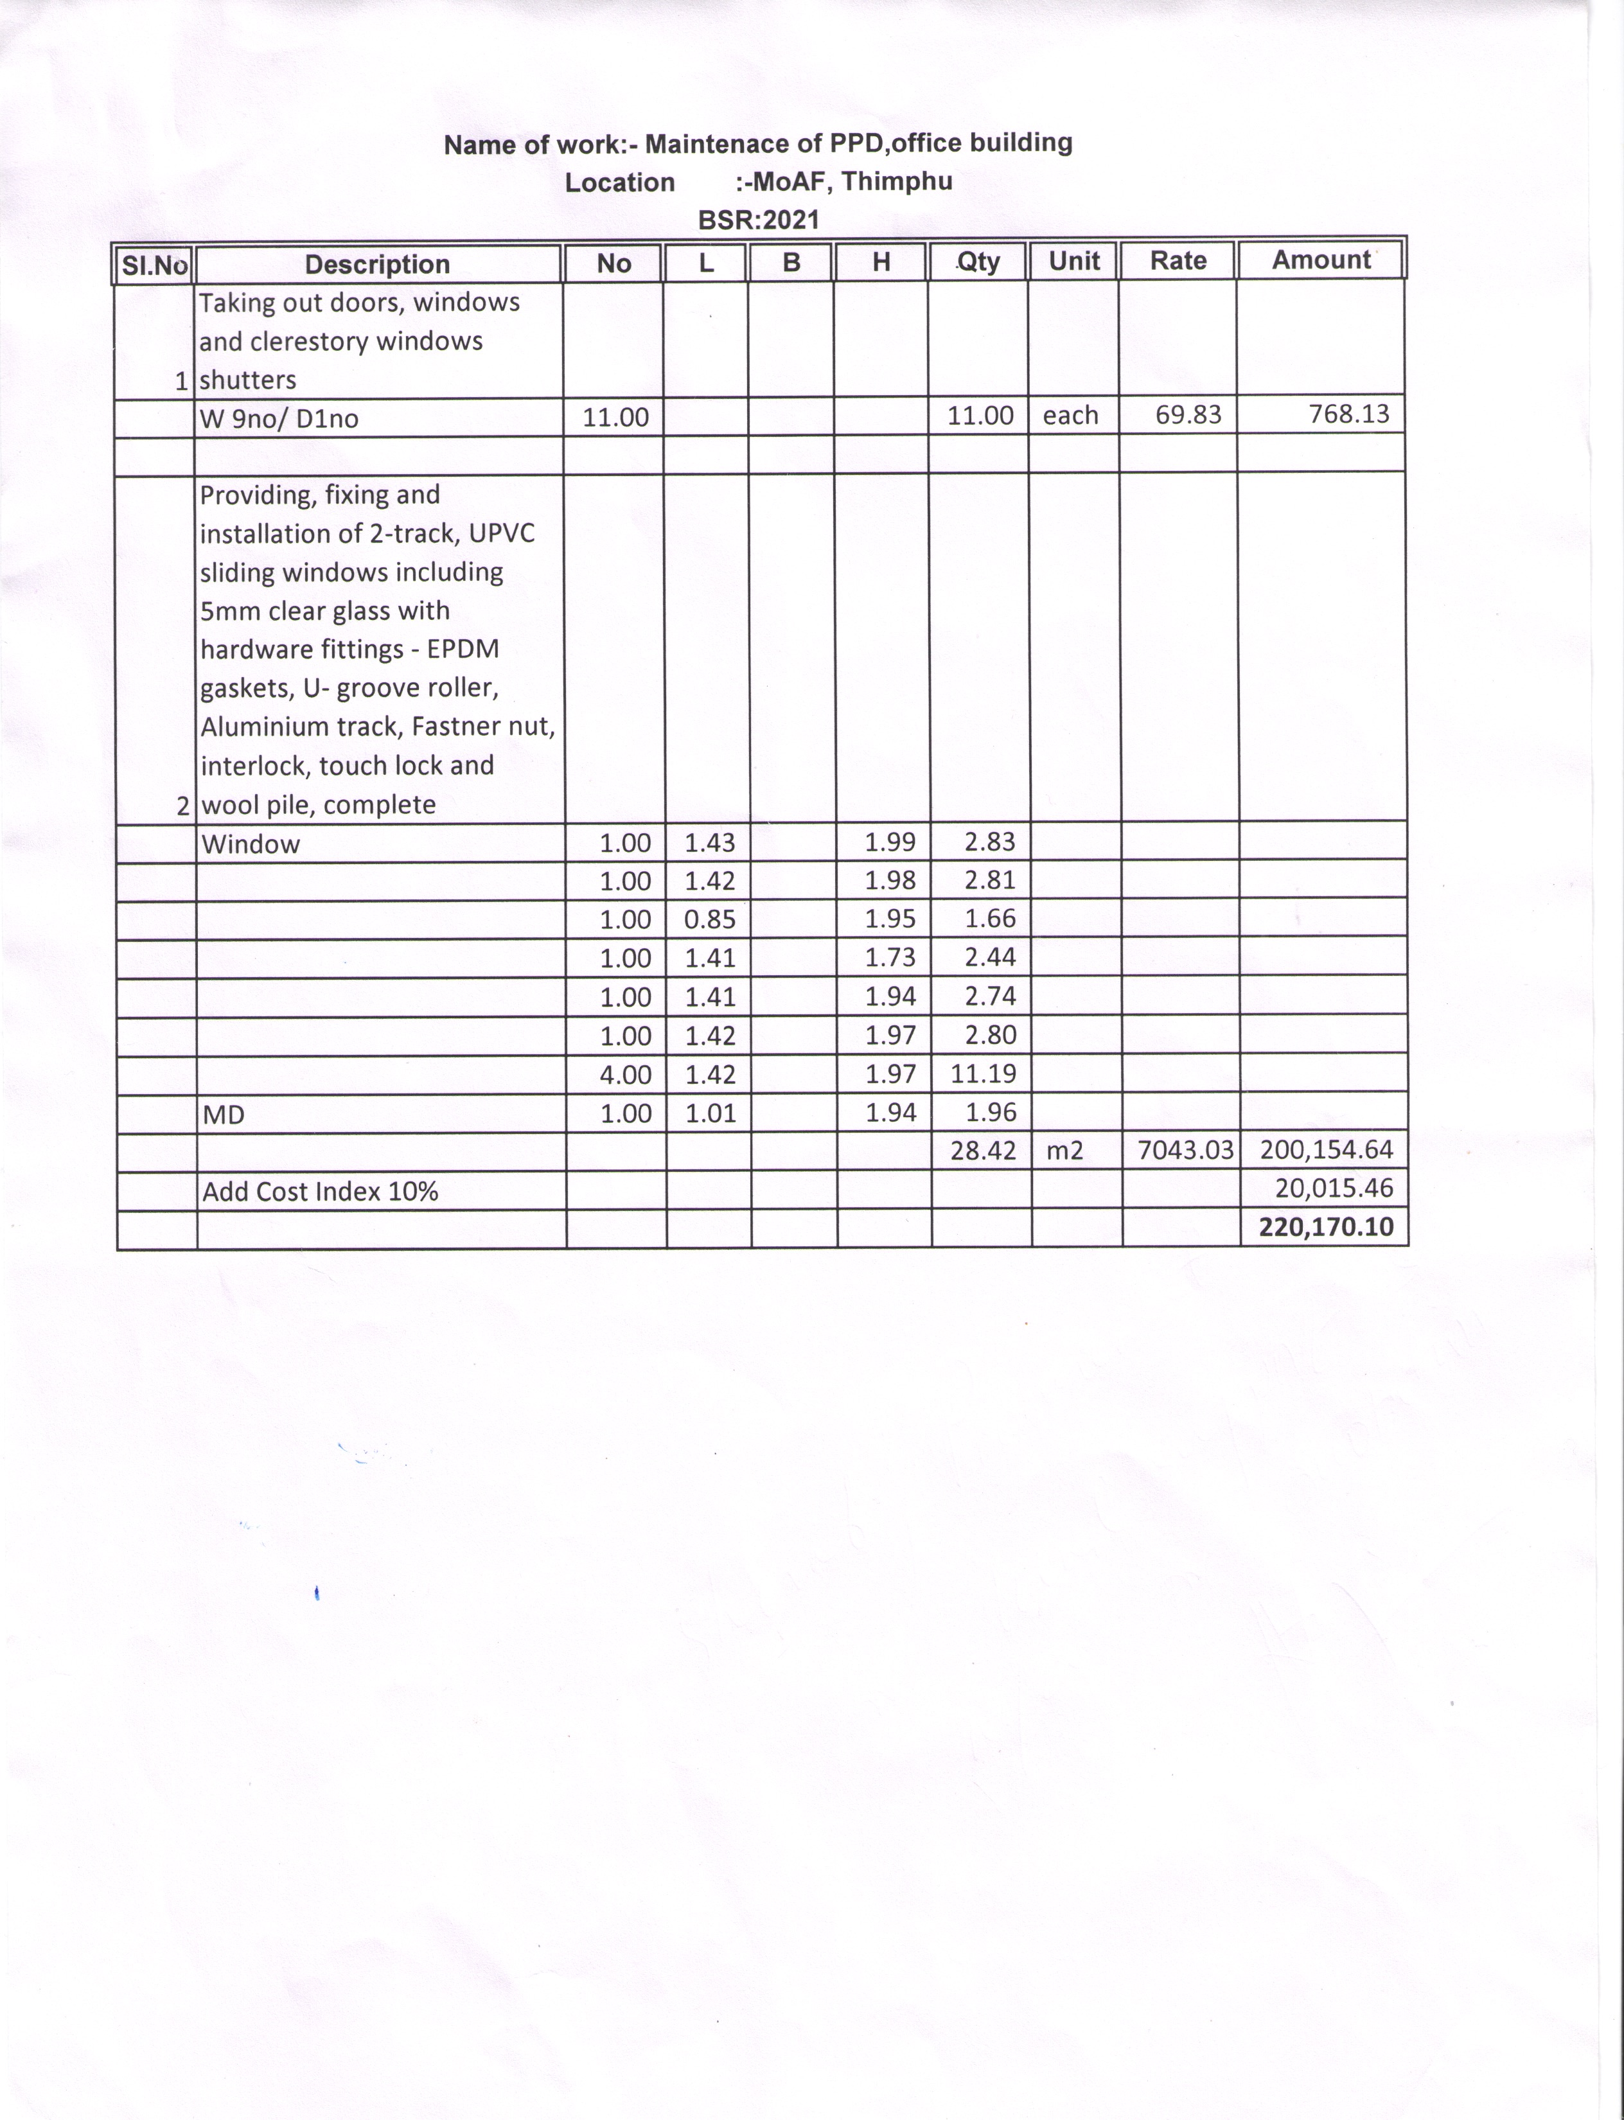

The Supplier is required to mention make / model (as applicable) of the goods to be supplied and must attach the appropriate original printed literature / brochures for the various items listed.

|  |  |
| --- | --- |
| Signature of Supplier | Supplier’s Stamp |
| Name of Supplier |
| Date |

**Documents required to be submitted as part of the Quotation**

The original and *copy(ies)* of quotation submitted by the Bidder shall comprise the following:

1. The bidder should be in the similar line of business [Heavy Vehicles].
2. A duly completed and signed priced quotation as per the Schedule of Items.
3. A valid Trade License[1];
4. A valid Tax Clearance Certificate;
5. The required bid security;
6. Technical Specification of the Goods to be supplied;
7. Manufacturer’s authorization to demonstrate that it has been duly authorized by the manufacturer or producer of the Goods to supply these goods in Bhutan. The Bidder / manufacturer should be able to demonstrate that they have the after sales facilities for maintenance of the type of vehicles being quoted.
8. Any other requirements specified in this document

**Terms and Conditions for the Supply of Goods and Payment**.

The Terms and Conditions hereinafter may only be varied with the written agreement of the Purchaser and no terms and conditions put forward at any time by the Supplier shall form any part of the Contract.

1. The Supplier shall be required to submit a performance security of 10% of the quoted price in the form of cash warrant, demand draft or unconditional Bank Guarantee issued by a financial institution located in Bhutan, which shall be furnished upon signing the contract. Performance security shall be valid till the end of warranty period and will be returned after the end of warranty period.
2. The supply of the goods and related services shall be completed within ***[30 days]*** days from the date of issue of the Purchase Order, or the signing of the contract (where applicable).
3. The Supplier shall agree to supply/perform the required after sales services/maintenance at the quoted price agreed in the contract.
4. The Purchaser shall arrange payment of the Invoice, within thirty (30) days upon submission of original Invoice and against the actual supplied quantities of goods as listed in the Purchase Order.
5. The quoted price shall include all taxes, duties, insurance and any other costs involved and nothing extra shall be paid.
6. Any goods found defective during the warranty period shall be replaced/repaired by the supplier at his cost. If the supplier fails to rectify and or replace the defective goods, the purchaser shall do it at the cost of the supplier.
7. The supplier shall supply the Goods required within 3 months from the date of placement of the purchase order or signing of contract. The supplier shall pay liquidated damages at the rate of 0.1% per day for each day of delay to a maximum of 10% of the quoted price.
8. The Purchaser may, by written notice, terminate the Purchase Order (or Contract if applicable) in whole or in part at any time for its convenience:
   1. if the Supplier fails to perform any other Terms and conditions specified with the Purchase Order, or exceeds the maximum amount of liquidated damages.
   2. if the Supplier fails to perform any other obligation(s) under the Purchase Order, or
   3. if the Supplier does not take any remedial action within a period of (7) seven calendar days after receipt of a notice of default from the Purchaser specifying the nature of the default(s), or
   4. if the Supplier, in the judgment of the Purchaser, has engaged in any corrupt or fraudulent practices in competing for or in executing the tasks under this Purchase Order; and
9. The Supplier shall provide the warranty, as stipulated in the Quotation document, for the goods to be supplied and confirm that if any faults are detected within the warranty period in the supplied/installed goods, the Supplier shall be bound to rectify the fault or replace the goods as the case may be. The security deposit shall be used to cover the cost of supplies not delivered or defective items not replaced or rectified.
10. The purchaser may procure any of the items from the open market in case the supplier fails to supply the goods within the stipulated time and realise the difference amount between the quoted price & market price from the security deposit

*[Purchaser to use normal Letter Head format*]

**PURCHASE ORDER FOR THE SUPPLY OF GOODS**

|  |  |
| --- | --- |
| **Purchase Order No:** | **Purchase Order Date:** |
| **From:**  *[name and address of Purchaser]* | *[Contact person,*  *Telephone Number*  *Fax Number*  *e-mail address]* |
|  |  |
| **To:**  *[name and address of the Supplier]* | *[Contact person,*  *Telephone Number*  *Fax Number*  *e-mail address*  *supplier reference]* |
| **Delivery date:** | **Order Value (Nu.):** |
| **Delivery terms:** |  |

The *[insert name of procuring agency]* has accepted your Quotation dated *[insert date]* for the supply of Goods as listed below and request you to supply the goods within the delivery date stated above, in the quantities and units and on these Terms and Conditions. For convenience a copy of your signed quotation is attached.

|  |  |  |  |  |  |
| --- | --- | --- | --- | --- | --- |
| ORDER ITEMS | | | | | |
| Item  No | Description | Supplier  Ref | Unit  Price | Qty | Total  Price |
|  |  |  |  |  |  |
|  |  |  |  |  |  |
|  |  |  |  |  |  |
|  |  |  |  |  |  |
|  |  |  |  |  |  |
|  |  |  |  |  |  |
|  |  |  |  |  |  |

In acceptance of this Purchase Order you are requested to sign below, at which time the Contract shall become legally binding upon both parties. You are also requested to confirm that you will be supplying the goods within the Delivery date mentioned above.

|  |  |
| --- | --- |
| For the Purchaser:  Signature | For the Supplier:  Signature |
| Print Name | Print name |
| Designation | Designation |
| Date | Date |

## 

## Contract Agreement

*[The successful Bidder shall fill in this form in accordance with the instructions indicated]*

THIS CONTRACT AGREEMENT made the *[insert number]* day of *[insert month]*, *[insert year]*,

BETWEEN

(1) *[insert complete name of Purchaser]*, a *[insert description of type of legal entity, for example, an agency of the Ministry of .... of the Government of Bhutan, or corporation incorporated under the laws of Bhutan]* and having its principal place of business at *[insert address of Purchaser]* (hereinafter called “the Purchaser”), and

(2) *[insert name of Supplier]*, a corporation incorporated under the laws of *[insert: country of Supplier]* and having its principal place of business at *[insert: address of Supplier]* (hereinafter called “the Supplier”).

WHEREAS the Purchaser invited Bids for certain Goods and ancillary services, viz., *[insert brief description of Goods and Services]* and has accepted a Bid by the Supplier for the supply of those Goods and Services in the sum of *[insert Contract Price in words and figures, expressed in the Contract currency/ies]* (hereinafter called “the Contract Price”).

NOW THIS AGREEMENT WITNESSETH AS FOLLOWS:

1. In this Agreement words and expressions shall have the same meanings as are respectively assigned to them in the Conditions of Contract referred to.

2. The following documents shall constitute the Contract between the Purchaser and the Supplier, and each shall be read and construed as an integral part of the Contract, viz.:

(a) This Contract Agreement;

(b) Terms and Conditions;

(c) Technical Requirements (including Schedule of Supply and Technical Specifications);

(e) The Supplier’s Bid and original Price Schedules;

(f) The Purchaser’s Notification of Award of Contract;

(g) The form of Performance Security;

(h) The form of Bank Guarantee for Advance Payment;

(i) *[insert here any other document(s) forming part of the Contract]*

3. This Contract shall prevail over all other Contract documents. In the event of any discrepancy or inconsistency within the Contract documents, then the documents shall prevail in the order listed above.

4. In consideration of the payments to be made by the Purchaser to the Supplier as hereinafter mentioned, the Supplier hereby covenants with the Purchaser to provide the Goods and Services and to remedy defects therein in conformity in all respects with the provisions of the Contract.

5. The Purchaser hereby covenants to pay the Supplier in consideration of the provision of the Goods and Related Services and the remedying of defects therein, the Contract Price or such other sum as may become payable under the provisions of the Contract at the times and in the manner prescribed by the Contract.

IN WITNESS whereof the parties hereto have caused this Agreement to be executed in accordance with the laws of Bhutan on the day, month and year indicated above.

For and on behalf of the Purchaser

Signed: *[insert signature]*

in the capacity of *[insert title or other appropriate designation]*

in the presence of *[insert signature]*

*[insert identification of official witness]*

For and on behalf of the Supplier

Signed: *[insert signature of authorized representative(s) of the Supplier]*

in the capacity of *[insert title or other appropriate designation]*

in the presence of *[insert signature]*

*[insert identification of official witness]*

## Performance Security

*[The bank, as requested by the successful Bidder, shall fill in this form in accordance with the instructions indicated]*

Date: *[insert date (as day, month, and year) of Bid submission]*

IFB No. and title*: [insert no. and title of bidding process]*

Bank’s Branch or Office: *[insert complete name of Guarantor]*

**Beneficiary:** *[insert complete name of Purchaser]*

**PERFORMANCE GUARANTEE No.:** *[insert Performance Guarantee number]*

We have been informed that *[insert complete name of Supplier]* (hereinafter called "the Supplier") has entered into Contract No*. [insert number]* dated *[insert day and month], [insert year]* with you, for the supply of *[description of Goods and related Services]* (hereinafter called "the Contract").

Furthermore, we understand that, according to the conditions of the Contract, a Performance Guarantee is required.

At the request of the Supplier, we hereby irrevocably undertake to pay you any sum(s) not exceeding *[insert amount(s)[2] in figures and words]* upon receipt by us of your first demand in writing declaring the Supplier to be in default under the Contract, without cavil or argument, or you needing to prove or to show grounds or reasons for your demand or the sum specified therein.

This Guarantee shall expire no later than the *[insert number]* day of *[insert month]* *[insert year]*,*[3]* and any demand for payment under it must be received by us at this office on or before that date. We agree to a one-time extension of this Guarantee for a period not to exceed *[six months] [one year]*, in response to the Purchaser’s written request for such extension, such request to be presented to us before the expiry of the Guarantee.

*[signatures of authorized representatives of the bank and the Supplier]*

## Bank Guarantee for Advance Payment

*[The bank, as requested by the successful Bidder, shall fill in this form in accordance with the instructions indicated.]*

Date: *[insert date (as day, month, and year) of Bid submission]*

IFB No. and title: *[insert number and title of bidding process]*

*[bank’s letterhead]*

**Beneficiary:** *[insert legal name and address of Purchaser]*

**ADVANCE PAYMENT GUARANTEE No.:** *[insert Advance Payment Guarantee no.]*

We, *[insert legal name and address of bank],* have been informed that *[insert complete name and address of Supplier]* (hereinafter called "the Supplier") has entered into Contract No. *[insert number]* dated *[insert date of Contract]* with you, for the supply of *[insert types of Goods to be delivered]* (hereinafter called "the Contract").

Furthermore, we understand that, according to the conditions of the Contract, an advance payment is to be made against an advance payment guarantee.

At the request of the Supplier, we hereby irrevocably undertake to pay you any sum or sums not exceeding in total an amount of *[insert amount(s) in figures and words]* upon receipt by us of your first demand in writing declaring that the Supplier is in breach of its obligation under the Contract because the Supplier used the advance payment for purposes other than toward delivery of the Goods.

It is a condition for any claim and payment under this Guarantee to be made that the advance payment referred to above must have been received by the Supplier in its account *[insert number* *and domicile of the account]*

This Guarantee shall remain valid and in full effect from the date of the advance payment received by the Supplier under the Contract until *[insert date[4]].*We agree to a one-time extension of this Guarantee for a period not to exceed *[six months][one year]*, in response to the Purchaser’s written request for such extension, such request to be presented to us before the expiry of the Guarantee.

_____________________   
*[signature(s) of authorized representative(s) of the bank]*

## 

## Bid Security (Bank Guarantee)

*[The Bank shall fill in this Bank Guarantee Form in accordance with the instructions indicated.]________________________________  
[insert Bank’s Name, and Address of Issuing Branch or Office]*

**Beneficiary:** ___________________ *[Name and Address of Purchaser]*

**Date:** ________________

**BID GUARANTEE No.:** _________________

We have been informed that *[insert name of the Bidder]* (hereinafter called "the Bidder") has submitted to you its Bid dated (hereinafter called "the Bid") for the execution of *[insert name of Contract]* under Invitation for Bids No. *[insert IFQ number]* (“the IFQ”).

Furthermore, we understand that, according to your conditions, Bids must be supported by a Bid Guarantee.

At the request of the Bidder, we *[insert name of Bank]* hereby irrevocably undertake to pay you any sum or sums not exceeding in total an amount of *[insert amount in figures]* (*[insert amount in words]*) upon receipt by us of your first demand in writing accompanied by a written statement stating that the Bidder is in breach of its obligation(s) under the Bid conditions, because the Bidder:

(a) has withdrawn its Bid during the period of Bid validity specified by the Bidder in the Form of Bid; or

(b) having been notified of the acceptance of its Bid by the Purchaser during the period of Bid validity, (i) fails or refuses to execute the Contract Form; or (ii) fails or refuses to furnish the Performance Security, if required, in accordance with the Instructions to Bidders.

This guarantee will expire: (a) if the Bidder is the successful Bidder, upon our receipt of copies of the contract signed by the Bidder and the Performance Security issued to you upon the instruction of the Bidder; or (b) if the Bidder is not the successful Bidder, upon the earlier of (i) our receipt of a copy of your notification to the Bidder of the name of the successful Bidder; or (ii) twenty-eight days after the expiration of the Bidder’s Bid.

Consequently, any demand for payment under this guarantee must be received by us at this office on or before that date.

**_____________________________**

*[signature(s)]*

## Sample Manufacturer’s Authorization

*[The Bidder shall require the Manufacturer to fill in this Form in accordance with the instructions indicated. This* *letter of authorization should be on the letterhead of the Manufacturer and be signed by a person with the proper authority to sign documents that are binding on the Manufacturer. The Bidder shall include it in its bid, if so indicated in the* ***BDS.****]*

Date: *[insert date of Bid Submission]*

Invitation for Bid No.: *[insert IFB number]*

Alternative No.: *[insert identification No if this is a Bid for an**alternative]*

To: *[insert complete name of the Purchaser]*

WHEREAS

We *[insert complete name of the Manufacturer]*, who are official manufacturers of *[insert type of Goods manufactured]*, having factories at *[insert full address(es) of the Manufacturer’s factory/ies]*, do hereby authorize *[insert complete name of Bidder]* to submit a Bid in relation to the Invitation for Quotation indicated above, the purpose of which is to provide the following Goods, manufactured by us, namely *[insert name and/or brief description of the Goods],* and subsequently to negotiate and sign the Contract.

We hereby extend our full guarantee and warranty in accordance with Clause 29 of the General Conditions of Contract, with respect to the Goods offered by the above firm.

Signed: *[insert signature(s) of authorized representative(s) of the Manufacturer]*

Name: *[insert complete name(s) of the authorized representative(s) of the Manufacturer]*

Title: *[insert title(s) of the authorized representative(s) of the Manufacturer]*

Duly authorized to sign this Authorization for and on behalf of *[insert complete name of the Bidder]*

Dated on the *[insert number]* day of *[insert month], [insert year]*.

1. The non submission of historical (b & c) documents should not become rejection criteria and should be given one chance to the bidder(s) to submit.
2. *The Bank shall insert the amount(s) specified in the SCC and denominated, as specified in the SCC, either in the currency(ies) of the Contract or a freely convertible currency acceptable to the Purchaser.*
3. *Date established in accordance with Clause 19.4 of the General Conditions of Contract (“GCC”). The Purchaser should note that in the event of an extension of the time to perform the Contract, the Purchaser would need to request an extension of this Guarantee from the Bank. Such request must be in writing and must be made prior to the expiration date established in the Guarantee.*
4. *Insert the Delivery date stipulated in the Contract Delivery Schedule. The Purchaser should note that in the event of an extension of the time to perform the Contract, the Purchaser would need to request an extension of this Guarantee from the bank. Such request must be in writing and must be made prior to the expiration date established in the Guarantee* 