**BUSINESS REQUIREMENT DOCUMENT**



**Building Resilient Commercial Smallholder Agriculture**

**(BRECSA)**

**Contents**

1. Project Profile Management 5

1.1. PPD User 5

1.2. Project Director (PD) 5

a) Impact, Goal and Objective for Project 6

b) Adding sub-component to the Component 6

c) Linking Output with the Component and sub-component 6

d) Linking Activity with the component, sub-component and Output 7

2. Project Planning 8

2.1. Annual Work Plan and Budget (AWPB) 8

2.1.1 Geog Extension Officer (GAEO, GLEO, EDMO, WFP, PMU) 8

2.1.2 Dzongkhag Agriculture Officer (DAO)/Dzongkhag Livestock Officer (DLO) 11

2.1.3 Physical M&E 11

2.1.4 Financial M&E 12

2.2 Procurement Planning 12

2.2.1 Procurement user 13

3. Progress Report 16

3.1 Physical Progress 16

3.1.1 GAEO/GLEO/WFP/RAMCO/PMU 17

3.1.2 Physical M&E 23

3.2 Financial Progress 24

3.2.1 DFO/ Financial M&E 24

3.2.1.1 Financial expense interface 24

3.2.1.2 Advance Interface 28

3.2.2 Financial M&E 30

4. Annual Outcomes Survey 31

4.1 Project Objective 31

4.2 Project Goal 32

4.3 Project Outreach 32

4.4 Project Outcome 33

4.5 Baseline Survey 33

5. Release 34

6. Configuration 35

6.1 Young Configuration 35

6.2 No. of People in a household 35

**7. Project Review 36**

7.1 Supervision Mission Report and Observation. 36

7.2 Project mid term review 36

7.3 Audit report and observation 36

7.4 Action Taken Report 37

7.4.1 Supervision Mission Report and Observation 37

7.4.2 Project mid term review 37

7.4.3 Audit report and observation 37

7.5 PSC minutes Recording 38

7.6 Completion Report 38

8. Master Management 39

9. User management 39

9.1 Users 39

10. Report 41

10.1. Geo Level 41

10.1.1 AWPB Proposed Report 41

10.1.2 AWPB Approved Report 41

10.1.3 Physical Progress submitted 41

10.2. DAO level 42

10.2.2 AWPB Approved Report 42

10.2.3 Physical Progress submitted by geog 42

10.2.4 Financial Progress submitted by DFO 43

10.3. DFO level 43

10.3.2 AWPB Approved Report 43

10.3.3 Physical Progress submitted by geog 44

10.3.4 Financial Progress submitted 44

10.4. Physical M&E level 45

10.4.1 AWPB Proposed Report 45

10.4.2 AWPB Approved Report 45

10.4.3 Physical Progress submitted by Geogs 45

10.4.4 Financial Progress submitted 46

10.4.5 Detail of Beneficiaries Report 46

10.4.6 M&E Report (M&E matrix) 46

10.4.7 Outcome Report 47

10.4.8 Outreach Report 47

10.4.9 Objective Report 47

10.4.10 Goal Report 47

10.5 Financial M&E 48

10.5.1 AWPB Proposed Report 48

10.5.2 AWPB Approved Report 48

10.5.3 Physical Progress submitted by Geogs 48

10.5.4 Financial Progress submitted 49

10.5.5 Financial 49

10.5.5.1 SoE Report 49

10.5.5.2 IFR Report 49

10.5.5.2.1 IFAD funds Forecast 49

10.5.5.2.2 Sources and use of fund 50

10.5.5.2.3 Variance analysis Quarter 50

10.5.5.2.4 Variance analysis Financial Year 50

10.5.5.2.5 Variance analysis cumulative 50

10.5.6 Procurement plan 51

10.5 PPD level (same like M&E) 51

10.6 Management level (Dashboard only) 51

**11. Annexure 53**

# Project Profile Management

## PPD User

**Business Requirement 1.1**

| BR No. | Business Requirement |
| --- | --- |
| 1.1.1 | PPD User should have a feature to create project, on behalf of project managements |
| 1.1.2 | Once the project has been created PPD should be able to create Project Director(PD) user against that project. |
| 1.1.3 | The PD user will have a right to create the users under that project. |

| Field Name | Input Type | Validation | Remarks |
| --- | --- | --- | --- |
| Project name | Text |  |  |

## Project Director (PD)

**Business Requirement 1.2**

| BR No. | Business Requirement |
| --- | --- |
| 1.2.1 | PD should be able to add project details against the project created. |
| 1.2.2 | PD and M&E users should have access to add items in the masters for their projects. |
| 1.2.3 | Followings are the details: |

**Input form**

### Impact, Goal and Objective for Project

| Field Name | Input Type | Validation | Remarks |
| --- | --- | --- | --- |
| Project name | Auto |  |  |
| Impact | long text |  |  |
| Goal | long text |  |  |
| Development Objectives | Long text |  |  |

### Adding sub-component to the Component

**Add more**

| Component | Select | Pull from masters | **Component and Sub-component mapping** |
| --- | --- | --- | --- |
| Sub-component | Select | Pull from masters |

**End of Add more**

### Linking Output with the Component and sub-component

**Add more**

| Component | Select | Pull from masters |  |
| --- | --- | --- | --- |
| Sub-component | Select | Pull from masters |  |
| Output | Select | Pull from masters |  |

**End of Add more**

### Linking Activity with the component, sub-component and Output

***Add More***

| Component | Select | Pull from masters |  |
| --- | --- | --- | --- |
| Sub-component | Select | Pull from masters |  |
| Output | Select | Pull from masters |  |
| Activity | Select | Pull from masters |  |

***End of Add more***

| BR No. | Business Requirement |
| --- | --- |
| 1.2.3 | should have a “Save as Draft” and save feature |

# Project Planning

## 2.1. Annual Work Plan and Budget (AWPB)

Process flow



### 2.1.1 Geog Extension Officer (GAEO, GLEO, EDMO, WFP, PMU)

| BR No. | Business Requirement |
| --- | --- |
| 2.1.1.1 | There should be a feature to submit the Annual Work Plan. |
| 2.1.1.2 | Upon submission, the application should be forwarded to the DAO or DLO, or M&E depending on the structure (Annexure Structure). |
| 2.1.1.3 | The submission is only once in a Financial Year. |

**Input form**

**add more**

| Field Name | Input Type | Validation | Remarks |
| --- | --- | --- | --- |
| Financial Year | Select | Pull from Master |  |
| Sector | Select | Pull from Master |  |
| Component | Select | Pull from Master |  |
| Sub-component | Select | Pull from Master |  |
| Output | Select | Pull from Master |  |
| Activity | Select | Pull from Master |  |
| Sub-Activity | Long Text |  |  |
| Indicator | Long Text |  |  |
| Quantity Planned | Number |  |  |
| Household | Number |  |  |
| Male (M) | Number |  |  |
| Female (F) | Number |  |  |
| Total Beneficiaries | Auto (M+F) |  |  |
| Category | Select | Pull from Master |  |
| GAFSP(A) | Number |  |  |
| IFAD Loan (B) | Number |  |  |
| RGoB (C) | Number |  |  |
| Beneficiary (D) | Number |  |  |
| Total | Auto (A+B+C+D) | Formula |  |
| Quarter | Select | Pull from masters |  |
| Location | Text |  |  |
| Collaborator | Text |  |  |
| Procurement Option | Select | Pull from masters |  |
| Procurement Method | Select | Pull from masters |  |
| Procurement Plan (PP) Review | Select | Pull from masters |  |
| Procurement Item | Text |  |  |
| RGoB OBC code | Select | Pull from masters |  |
| AWPB PP code | Text |  |  |
| Remarks | Text |  |  |
| Status | Auto | by default it should be Proposal |  |
| Save Draft | Button |  |  |
| Submit | Button |  |  |

end of add more

### 2.1.2 Dzongkhag Agriculture Officer (DAO)/Dzongkhag Livestock Officer (DLO)

| BR No. | Business Requirement |
| --- | --- |
| 2.1.2.1 | Should be able to view all the applications submitted by the geogs under that Dzongkhag. |
| 2.1.2.2 | Should have edit and forward (to M&E) buttons. |
| 2.1.2.3 | Should be able to edit all the fields. |
| 2.1.2.4 | Should have a reject button against each sub-activity proposed. while rejecting the corresponding sub-activity should be deleted from the system. |

### 

### 2.1.3 Physical M&E

| BR No. | Business Requirement |
| --- | --- |
| 2.1.3.1 | Should be able to view all the applications from 205 Geogs. |
| 2.1.3.2 | Should be able to edit all the details. |
| 2.1.3.3 | Should have approve and reject buttons |
| 2.1.3.4 | There should be status selection before approving. The status updated by Physical M&E against the proposal application should update all the status down the line. |
| 2.1.3.5 | Upon approving the application, notify respective Geogs and Dzongkhags through system dashboard and email. |
| 2.1.3.6 | If rejected, the proposed sub-activity should be deleted from the system. |
| 2.1.3.7 | Should be able to download in Word, PDF, and Excel formats. |

## 

### 2.1.4 Financial M&E

| BR No. | Business Requirement |
| --- | --- |
| 2.1.3.1 | Should be able to view all the applications from 205 Geogs. |
| 2.1.3.7 | Should be able to download in Word, PDF, and Excel formats. |

## 

## 2.2 Procurement Planning



### 2.2.1 Procurement user

| BR No. | Business Requirement |
| --- | --- |
| 2.2.1 | Should have an **interface** from where the procurement plan can be derived based on the plan submitted by the Geogs. With filters “Category (goods, services, and works), Dzongkhag,Geog, sector PP Method and PP Review”. |
| 2.2.2 | Should be able to download in PDF, Word, and Excel format. |
|  |  |

**Input Form**

| Field Name | Input Type | Validation | Remarks |
| --- | --- | --- | --- |
| **Profile Information** | | | |
| Agency | Auto | use Dzongkhag of the user as agency |  |
| Sector | Auto |  |  |
| Component | Auto |  |  |
| Sub-component | Auto |  |  |
| Category | Auto |  |  |
| Activity | Auto |  |  |
| Sub-Activity | Auto |  |  |
| IFAD Loan (A) | Auto |  |  |
| GAFSP (B) | Auto |  |  |
| Total | Auto (A+B) |  |  |
| Implementing Quarter | Auto |  |  |
| Procurement Method | Auto |  |  |
| Procurement Plan (PP) Review | Auto |  |  |

| Field Name | Input Type | Validation | Remarks |
| --- | --- | --- | --- |
| **Basic Data** | | | |
| Package/Lot No | Select | Pull from masters |  |
| Pre or Post Qualification | Select |  |  |
| Plan vs Actual | Select | Pull from masters |  |
| **Pre. Qualification** | | | |
| Preparation of Pre Qual docs | Text |  |  |
| No Objection Date (PreQual docs) | Date |  |  |
| PreQual Invitation Date | Date |  |  |
| PreQual Closing date | Date |  |  |
| No Objection Date (PreQual Report) | Date |  |  |
| **Bidding process** | | | |
| No Objection Date | Date |  |  |
| Bid Invitation date | Date |  |  |
| Bid Closing/Opening | Date |  |  |
| **Bid Evaluation** | | | |
| Submission of Technical Evaluation report | Text |  |  |
| No objection Date | date |  |  |
| Submission Combined Evaluation report | Text |  |  |
| No-Objection Date | date |  |  |
| Plan Vs Actual | Select | Pull from masters |  |
| **Contract Award and Signature** | | | |
| Date of Contract Award | Date |  |  |
| Date of Contract Signature | Date |  |  |
| MoF’s Directive | Text |  |  |
| Save as Draft | Button |  |  |
| Save | Button |  |  |

| BR No. | Business Requirement |
| --- | --- |
| 2.2.3 | There should be an interface to upload files for all the select options available under “Package/Lot No” as follows. |

**Input form**

| Field Name | Input Type | Validation | Remarks |
| --- | --- | --- | --- |
| **File upload** | | | |
| Package/Lot No | Select | Pull from masters |  |
| Submission of Pre-Qual Report | file upload |  |  |
| Bid document | file upload |  |  |
| Submission of Technical Evaluation report | file upload |  |  |

# Progress Report

## 3.1 Physical Progress



**Process flow**

### 3.1.1 GAEO/GLEO/WFP/RAMCO/PMU

| BR No. | Business Requirement |
| --- | --- |
| 3.1.1.1 | There should be a physical reporting feature against each approved sub-activity in the AWPB. |

**Input form**

**Project Activity Detail**

| Field Name | Input Type | Validation | Remarks |
| --- | --- | --- | --- |
| Financial Year | Auto |  |  |
| Sector | Auto |  |  |
| Component | Auto |  |  |
| Sub-component | Auto |  |  |
| Output | Auto |  |  |
| Activity | Auto |  |  |
| Sub-Activity | Auto |  |  |
| Indicator | Auto |  |  |
| Quantity Planned | Auto |  |  |
| Household | Auto |  |  |
| Male (M) | Auto |  |  |
| Female (F) | Auto |  |  |
| Total Beneficiaries | Auto |  |  |
| Category | Auto |  |  |
| GAFSP (A) | Auto |  |  |
| IFAD Loan (B) | Auto |  |  |
| RGoB (C) | Auto |  |  |
| Beneficiary (D) | Auto |  |  |
| Total | Auto |  |  |
| Quarter | Auto |  |  |
| Location | Auto |  |  |
| Collaborator | Auto |  |  |

**Input Form**

**Selection**

| Field Name | Input Type | Validation | Remarks |
| --- | --- | --- | --- |
| Beneficiary Type | Select (individual or Group) | Pull from masters |  |

**If Individual**

| Field Name | Input Type | Validation | Remarks |
| --- | --- | --- | --- |
| Bio Data | | | |
| CID | Number |  |  |
| Name | Auto | Pull from DCRC |  |
| Village | Auto | Pull from DCRC |  |
| Geog | Auto | Pull from DCRC |  |
| Dzongkhag | Auto | Pull from DCRC |  |
| Gender | Auto | Pull from DCRC |  |
| House No | Auto | Pull from DCRC |  |
| Support provided | Select |  |  |
| Present Address | | | |
| Dzongkhag | Select | Pull from masters |  |
| Geog | Select | Pull from masters |  |
| Village | Select | Pull from masters |  |
| Disable | Radio Button | Yes/No |  |
| Climate resilient Technology | Radio button | Yes/No |  |
| if Yes(Climate resilient Technology) if no nothing addition to capture | | | |
| Type | Select | Pull from masters |  |
| Count: | Number |  |  |
| Unit | Select | Pull from masters |  |
| end of if yes (Climate resilient Technology) |  |  |  |
| Access to Finance | Radio button | Yes/No |  |
| if Yes(Access to Finance) if no nothing addition to capture | | | |
| Bank name | Select | Pull from master |  |
| Amount | Number |  |  |
| Remarks | Text |  |  |
| end of if yes(Access to Finance) |  |  |  |

**end of If individual**

| Field Name | Input Type | Validation | Remarks |
| --- | --- | --- | --- |
| Quantity Achieved | Number |  |  |
| Unit | Select | Pull from Master |  |

**If Group (add all members)**

| Field Name | Input Type | Validation | Remarks |
| --- | --- | --- | --- |
| Group [old or new] | Select (old or new) | Pull from masters |  |

**Add more**

| Field Name | Input Type | Validation | Remarks |
| --- | --- | --- | --- |
| Bio Data | | | |
| CID | Number |  |  |
| Name | Auto | Pull from DCRC |  |
| Village | Auto | Pull from DCRC |  |
| Geog | Auto | Pull from DCRC |  |
| Dzongkhag | Auto | Pull from DCRC |  |
| Gender | Auto | Pull from DCRC |  |
| Household No | Auto | Pull from DCRC |  |
| Head of household | Auto (yes or No) |  |  |
| Support provided | Select | Pull from masters |  |
| Present Address | | | |
| Dzongkhag | Select | Pull from masters |  |
| Geog | Select | Pull from masters |  |
| Village | Select | Pull from masters |  |
| Disable | Radio Button | Yes/No |  |
| Climate resilient Technology | Radio button | Yes/No |  |
| if Yes(Climate resilient Technology) if no nothing addition to capture | | | |
| Type | Select | Pull from masters |  |
| Count: | Number |  |  |
| Unit | Select | Pull from masters |  |
| end if Yes(Climate resilient Technology) | | | |
| Access to Finance | Radio button | Yes/No |  |
| if Yes (Access to Finance) if no nothing addition to capture | | | |
| Bank name | Select | Pull from master |  |
| Amount | Number |  |  |
| Remarks | Text |  |  |
| end of if Yes (Access to Finance) | | | |
| Group Name | Text |  |  |
| Membership | Select (Chairman or member) | Pull from masters |  |

**end of If**

**end of add more**

| Field Name | Input Type | Validation | Remarks |
| --- | --- | --- | --- |
| Quantity Achieved | Number |  |  |
| Unit | Select | Pull from Master |  |

**Summary of members added**

| Field Name | Input Type | Validation | Remarks |
| --- | --- | --- | --- |
| HouseHold Headed by women | Auto (total number of HouseHold Headed by women) |  |  |
| Disability | Auto ( number of disabled member in a group) |  |  |
| Male (M) | Auto (Total male members) |  |  |
| Female (F) | Auto (Female members) |  |  |
| Young | Auto (Youth male + Female members) |  | **Those whose age is less than the age configured in the Configuration module will fall under young.** |
| Total | Auto (M + F) |  |  |
| Land Bought under climate resilient management in Acre | Auto ( total of all Acreage) |  |  |

**end of If Group**

| BR No. | Business Requirement |
| --- | --- |
| 3.1.1.2 | There should be a “Save as Draft” feature |
| 3.1.1.3 | Upon submission, the application should be forwarded to M&E and a copy to DFO. |

### 

### 3.1.2 Physical M&E

| BR No. | Business Requirement |
| --- | --- |
| 3.1.2.1 | Should be able to view the Physical progress submitted by GEO. |
| 3.1.2.2 | Should be able to edit the progress based on the physical inspection done by the M&E. |

## 

## 3.2 Financial Progress

Process flow

### 3.2.1 DFO/ Financial M&E

#### 3.2.1.1 Financial expense interface

| BR No. | Business Requirement |
| --- | --- |
| 3.2.1.1.1 | There should be a financial reporting feature to report Financial progress against each physical progress submitted by Geog |
| 3.2.1.1.2 | Financial Reporting will be enabled only against those activities whose physical progress report has been submitted. |
| 3.2.1.1.3 | Use Accordion |

**Input form**

**AWPB Details ( - )**

| Field Name | Input Type | Validation | Remarks |
| --- | --- | --- | --- |
| Financial Year | Auto |  |  |
| Sector | Auto |  |  |
| Component | Auto |  |  |
| Sub-component | Auto |  |  |
| Output | Auto |  |  |
| Activity | Auto |  |  |
| Sub-Activity | Auto |  |  |
| Category | Auto |  |  |
| IFAD | Auto |  |  |
| Loan | Auto |  |  |
| RGoB | Auto |  |  |
| BEN | Auto |  |  |
| RGoB OBC code | Auto |  |  |
| Remarks | Auto |  |  |
| Agencies | Auto |  |  |

**Physical Progress Details ( - )**

| Field Name | Input Type | Validation | Remarks |
| --- | --- | --- | --- |
| CID | Auto |  |  |
| Name | Auto |  |  |
| Village | Auto |  |  |
| Geog | Auto |  |  |
| Dzongkhag | Auto |  |  |
| Gender | Auto |  |  |
| House No | Auto |  |  |
| Support provided | Auto |  |  |
| Type | Auto |  |  |
| Quantity | Auto |  |  |
| Unit | Auto |  |  |
| Count | Auto |  |  |
| Disability | Auto |  |  |
| Woman Headed Household | Auto |  |  |
| Name of a group | Auto |  |  |
| Commodity | Auto |  |  |

**Financial progress**

| Field Name | Input Type | Validation | Remarks |
| --- | --- | --- | --- |
| Full Description of Payment | Text |  |  |
| Name of the Payee/ Contractor, Supplier, Service Provider | Text |  |  |
| Contract and/or Invoice Number /Note Sheet No | Text |  |  |
| Vouchers no. | Text |  |  |
| Amount (A) | Number |  |  |
| Tax Amount | Number |  |  |
| Advance | radio button | **yes/ no** | **if yes then the amount should not be booked as expenditure, rather the application should be moved to the Advance interface.** |
| Date of Payment | Select | Cannot accept future date | **if advance is no** |
| Date of Advance | Select | Cannot accept future date | **if advance is yes** |
| Exchange rate (ER) | Text |  |  |
| Withdrawal Application  Currency  (USD Dollar ) | Auto | Formula ( ER / A) |  |
| Payment Reference to Bank Account or Cash Book (e.g. value date or transaction ID)/ Cheque number | Text |  |  |
| Submit | Button |  |  |

| BR No. | Business Requirement |
| --- | --- |
| 3.2.1.1.4 | There should be a “Save as Draft” feature |
| 3.2.1.1.5 | Upon submission, the application should be forwarded to Financial M&E. |
| 3.2.1.1.6 | If the advance is YES, the Submit button should be disabled and “Book Advance” button should be enabled |
| 3.2.1.1.7 | If the advance is NO, the Submit button should be enabled and the amount should be booked as expenditure. |
| 3.2.1.1.8 | If the “Book Advance” Button is clicked then the amount **should not be booked as expenditure, rather the application should be moved to the Advance Adjustment interface.** |

#### 3.2.1.2 Advance Interface

| BR No. | Business Requirement |
| --- | --- |
| 3.2.1.2.1 | All the applications that are booked as Advance should be displayed. |
| 3.2.1.2.2 | There should be an “adjust the advance” button against all the applications booked as advance, while adjusting the advance there should be a field to capture whether the adjustment is “full adjustment” or “Partial adjustment”. |

| Field Name | Input Type | Validation | Remarks |
| --- | --- | --- | --- |
| Adjustment Type | Select (Partial Adjustment or Full Adjustment) |  |  |
| Full Description of Payment | Text |  |  |
| Name of the Payee/ Contractor, Supplier, Service Provider | Text |  |  |
| Contract and/or Invoice Number /Note Sheet No | Text |  |  |
| Vouchers no. | Text |  |  |
| Amount (A) | Number | should be not more that the advance amount |  |
| Tax Amount | Number |  |  |
| Date | Select | Cannot accept future date |  |
| Exchange rate (ER) | Text |  |  |
| Withdrawal Application  Currency  (USD Dollar ) | Auto | Formula ( ER / A) |  |
| Payment Reference to Bank Account or Cash Book (e.g. value date or transaction ID)/ Cheque number | Text |  |  |
| Submit | Button |  |  |

| BR No. | Business Requirement |
| --- | --- |
| 3.2.1.2.3 | If Partial advance adjustment is selected, compare the advance amount with the current adjustment amount. The difference of the advance amount with the current adjustment amount should be kept in the advance interface until the “Full adjustment” is selected, and the “current adjustment” amount should be booked as expenditure. |
| 3.2.1.2.4 | If Full adjustment is selected no matter what the amount is it should be booked as expenditure, and remove the application from Advance interface. |

### 3.2.2 Financial M&E

| BR No. | Business Requirement |
| --- | --- |
| 3.2.2.1 | Should be able to view and edit the progress submitted by DFO. |
| 3.2.2.2 | Should be able to view the physical progress submitted by PMU,WFP, RAMCO users and accordingly Financial M&E should report financial progress for those Physical progress. |
| 3.2.2.3 | Report should be downloadable in PDF, Word and Excel formats. |

# Annual Outcomes Survey

Outcome Indicator Survey

| BR No. | Business Requirement |
| --- | --- |
| 4 | This module is only for M&E. |

## 4.1 Project Objective

Add more

| Field Name | Input Type | Validation | Remarks |
| --- | --- | --- | --- |
| Core indicator | Select | Pull from masters | **Core indicator and indicator mapping** |
| Indicator | Select |
| Indicator Description | Text |  |  |
| Unit | Select | Pull from masters |  |
| Baseline | Number |  |  |
| Target | Number |  |  |
| Annual Progress | Number |  |  |

end of add more

## 

## 4.2 Project Goal

Add more

| Field Name | Input Type | Validation | Remarks |
| --- | --- | --- | --- |
| Core indicator | Select | Pull from masters | **Core indicator and indicator mapping** |
| Indicator | Select |
| Indicator Description | Text |  |  |
| Unit | Select | Pull from masters |  |
| Baseline | Number |  |  |
| Target | Number |  |  |
| Annual Progress | Number |  |  |

end of addmore

## 4.3 Project Outreach

Add more

| Field Name | Input Type | Validation | Remarks |
| --- | --- | --- | --- |
| Core indicator | Select | Pull from masters | **Core indicator and indicator mapping** |
| Indicator | Select |
| Indicator Description | Text |  |  |
| Unit | Select | Pull from masters |  |
| Baseline | Number |  |  |
| Target | Number |  |  |

end of add more

## 4.4 Project Outcome

Add more

| Field Name | Input Type | Validation | Remarks |
| --- | --- | --- | --- |
| Core indicator | Select | Pull from masters | **Core indicator and indicator mapping** |
| Indicator | Select |
| Indicator Description | Text |  |  |
| Unit | Select | Pull from masters |  |
| Baseline | Number |  |  |
| Target | Number |  |  |

end of add more

## 4.5 Baseline Survey

Add more

| Field Name | Input Type | Validation | Remarks |
| --- | --- | --- | --- |
| Core indicator | Select | Pull from masters | **Core indicator and indicator mapping** |
| Indicator | Select |
| Indicator Description | Text |  |  |
| Unit | Select | Pull from masters |  |
| Baseline | Number |  |  |
| Target | Number |  |  |

end of add more

# Release

## 

| Field Name | Input Type | Validation | Remarks |
| --- | --- | --- | --- |
| Country | Auto |  |  |
| Name of Project | Auto |  |  |
| IFAD Instrument number | Text |  |  |
| List other instruments if applicable | Text |  |  |
| Expressed in Designated Account Denomination Currency | Select | pull from masters |  |

# Configuration

## 6.1 Young Configuration

| Field Name | Input Type | Validation | Remarks |
| --- | --- | --- | --- |
| DoB | Date |  |  |
| save | button |  |  |

## 6.2 No. of People in a household

| Field Name | Input Type | Validation | Remarks |
| --- | --- | --- | --- |
| Average No. of Person in Household | Number |  |  |
| save | button |  |  |

# Project Review

## 7.1 Supervision Mission Report and Observation.

| Field Name | Input Type | Validation | Remarks |
| --- | --- | --- | --- |
| Report | File upload |  |  |
| Remarks | Long Text |  |  |
| save | button |  |  |

## 7.2 Project mid term review

| Field Name | Input Type | Validation | Remarks |
| --- | --- | --- | --- |
| Report | File upload |  |  |
| Remarks | Long Text |  |  |
| save | button |  |  |

## 7.3 Audit report and observation

| Field Name | Input Type | Validation | Remarks |
| --- | --- | --- | --- |
| Report | File upload |  |  |
| Remarks | Long Text |  |  |
| save | button |  |  |

## 7.4 Action Taken Report

### 7.4.1 **Supervision Mission Report and Observation**

| Field Name | Input Type | Validation | Remarks |
| --- | --- | --- | --- |
| Report | File upload |  |  |
| Remarks | Long Text |  |  |
| save | button |  |  |

### 7.4.2 Project mid term review

| Field Name | Input Type | Validation | Remarks |
| --- | --- | --- | --- |
| Report | File upload |  |  |
| Remarks | Long Text |  |  |
| save | button |  |  |

### 7.4.3 Audit report and observation

| Field Name | Input Type | Validation | Remarks |
| --- | --- | --- | --- |
| Report | File upload |  |  |
| Remarks | Long Text |  |  |
| save | button |  |  |

## 7.5 PSC minutes Recording

| Field Name | Input Type | Validation | Remarks |
| --- | --- | --- | --- |
| PSC meeting | Text |  |  |
| Minutes | File upload |  |  |
| Remarks | Long Text |  |  |
| save | button |  |  |

## 7.6 Completion Report

| Field Name | Input Type | Validation | Remarks |
| --- | --- | --- | --- |
| Report | File upload |  |  |
| Remarks | Long Text |  |  |
| save | button |  |  |

# Master Management

**Business Requirement 8**

| BR No. | Business Requirement |
| --- | --- |
| 8.1 | All the fields in the input forms which have the “select” option should be managed from the masters. |
| 8.2 | In the masters there should add feature |
| 8.3 | There should be a disabled feature (entry once made in the master cannot not be deleted, instead disabled), once disabled it should not be viewable in the input forms under the select option. |
| 8.4 | There should be enable Feature (enable the disabled entry) |

# User management

## 9.1 Users

* Admin
* Project Director
* Physical M&E
* Finance M&E
* DFO
* DAO/DLO
* GAEO/GLEO/WFP/RAMCO/PMU
* Management
* PMU Procurement

Input form

| Field Name | Input Type | Validation | Remarks |
| --- | --- | --- | --- |
| Project Name | select |  |  |
| Name | Text |  |  |
| Employee ID | Text |  |  |
| Designation | Select |  |  |
| Dzongkhag | Select |  |  |
| Geog | Select |  |  |
| Sector | Select |  |  |
| Role | Multi-select |  |  |
| create user | Button |  |  |

**Business Requirement 9**

| BR No. | Business Requirement |
| --- | --- |
| 9.1 | Refer annexure organizational structure |

# Report

## 10.1. Geo Level

### 10.1.1 **AWPB Proposed Report**

| BR No. | Business Requirement |
| --- | --- |
| 10.1.1.1 | Should be able to view the proposed AWPB by the user. |
| 10.1.1.2 | Should have “from date” and “to date” and all other possible filters based on the AWPB input form. |
| 10.1.1.3 | Report should be downloadable in PDF, Word and Excel formats. |

### 10.1.2 AWPB Approved Report

| BR No. | Business Requirement |
| --- | --- |
| 10.1.2.1 | Should be able to view the Approved AWPB |
| 10.1.2.2 | Should have “from date” and “to date” and all other possible filters based on the AWPB input form. |
| 10.1.2.3 | Report should be downloadable in PDF, Word and Excel formats. |

### 10.1.3 Physical Progress submitted

| BR No. | Business Requirement |
| --- | --- |
| 10.1.2.1 | Should be able to view the Physical progress submitted |
| 10.1.2.2 | Should have “from date” and “to date” and all other possible filters based on the AWPB input form. |
| 10.1.2.3 | Report should be downloadable in PDF, Word and Excel formats. |

## 10.2. DAO level

**10.2.1 AWPB Proposed Report**

| BR No. | Business Requirement |
| --- | --- |
| 10.2.1.1 | Should be able to view the proposed AWPB by the Geog users under his dzongkhag. |
| 10.2.1.2 | Should have “from date” and “to date” , geog wise, and all other possible filters based on the AWPB input form. |
| 10.2.1.3 | Report should be downloadable in PDF, Word and Excel formats. |

### 10.2.2 AWPB Approved Report

| BR No. | Business Requirement |
| --- | --- |
| 10.2.2.1 | Should be able to view the Approved AWPB under his dzongkhag |
| 10.2.2.2 | Should have “from date” and “to date”, geog wise and all other possible filters based on the AWPB input form. |
| 10.2.2.3 | Report should be downloadable in PDF, Word and Excel formats. |

### 10.2.3 Physical Progress submitted by geog

| BR No. | Business Requirement |
| --- | --- |
| 10.2.3.1 | Should be able to view the Physical progress submitted by geogs under that dzongkhag |
| 10.2.3.2 | Should have “from date” and “to date” and all other possible filters based on the AWPB input form. |
| 10.2.3.3 | Report should be downloadable in PDF, Word and Excel formats. |

### 10.2.4 Financial Progress submitted by DFO

| BR No. | Business Requirement |
| --- | --- |
| 10.2.4.1 | Should be able to view the Financial progress submitted by DFO under his dzongkhag |
| 10.2.4.2 | Should have “from date” and “to date” and all other possible filters based on the AWPB input form. |
| 10.2.4.3 | Report should be downloadable in PDF, Word and Excel formats. |

## 10.3. DFO level

**10.3.1 AWPB Proposed Report**

| BR No. | Business Requirement |
| --- | --- |
| 10.3.1.1 | Should be able to view the proposed AWPB by the Geog users under his dzongkhag. |
| 10.3.1.2 | Should have “from date” and “to date” , geog wise, and all other possible filters based on the AWPB input form. |
| 10.3.1.3 | Report should be downloadable in PDF, Word and Excel formats. |

### 10.3.2 AWPB Approved Report

| BR No. | Business Requirement |
| --- | --- |
| 10.3.2.1 | Should be able to view the Approved AWPB under his dzongkhag |
| 10.3.2.2 | Should have “from date” and “to date”, geog wise and all other possible filters based on the AWPB input form. |
| 10.3.2.3 | Report should be downloadable in PDF, Word and Excel formats. |

### 10.3.3 Physical Progress submitted by geog

| BR No. | Business Requirement |
| --- | --- |
| 10.3.3.1 | Should be able to view the Physical progress submitted by geogs under that dzongkhag |
| 10.3.3.2 | Should have “from date” and “to date” and all other possible filters based on the AWPB input form. |
| 10.3.3.3 | Report should be downloadable in PDF, Word and Excel formats. |

### 

### 10.3.4 Financial Progress submitted

| BR No. | Business Requirement |
| --- | --- |
| 10.2.4.1 | Should be able to view the Financial progress submitted |
| 10.2.4.2 | Should have “from date” and “to date”, gewog wise, and all other possible filters based on the AWPB input form. |
| 10.2.4.3 | Report should be downloadable in PDF, Word and Excel formats. |

### 

## 10.4. Physical M&E level

### 10.4.1 AWPB Proposed Report

| BR No. | Business Requirement |
| --- | --- |
| 10.4.1.1 | Should be able to view the proposed AWPB by the 205 Geog users |
| 10.4.1.2 | Should have “from date” and “to date”, geog wise, and all other possible filters based on the AWPB input form. |
| 10.4.1.3 | Report should be downloadable in PDF, Word, and Excel formats. |

### 10.4.2 AWPB Approved Report

| BR No. | Business Requirement |
| --- | --- |
| 10.4.2.1 | Should be able to view the Approved AWPB |
| 10.4.2.2 | Should have “from date” and “to date”, Dzongkhag wise, geog wise and all other possible filters based on the AWPB input form. |
| 10.4.2.3 | Report should be downloadable in PDF, Word, and Excel formats. |

### 10.4.3 Physical Progress submitted by Geogs

| BR No. | Business Requirement |
| --- | --- |
| 10.4.3.1 | Should be able to view the Physical progress submitted by 205 geogs |
| 10.4.3.2 | Should have “from date” and “to date”, dzongkhag wise, geog wise and all other possible filters based on the AWPB input form. |
| 10.4.3.3 | Report should be downloadable in PDF, Word and Excel formats. |

### 

### 10.4.4 Financial Progress submitted

| BR No. | Business Requirement |
| --- | --- |
| 10.4.4.1 | Should be able to view the Financial progress submitted |
| 10.4.4.2 | Should have “from date” and “to date”, gewog wise, and all other possible filters based on the AWPB input form. |
| 10.4.4.3 | Report should be downloadable in PDF, Word and Excel formats. |

### 10.4.5 Detail of Beneficiaries Report

| BR No. | Business Requirement |
| --- | --- |
| 10.4.5.1 | Should be able to view the beneficiaries |
| 10.4.5.2 | Should have “from date” and “to date”, gewog wise, and all other possible filters based on the Physical Progress input form. |
| 10.4.5.3 | Report should be downloadable in PDF, Word and Excel formats. |
| 10.4.5.4 | Refer annexure Beneficiaries Report format. |

### 10.4.6 M&E Report (M&E matrix)

| BR No. | Business Requirement |
| --- | --- |
| 10.4.6.1 | Refer annexure M&E Report format. |
| 10.4.6.2 | For over all count it should be total of Unique CID in all component |
| 10.4.6.3 | Report should be downloadable in PDF, Word and Excel formats. |

### 10.4.7 Outcome Report

| BR No. | Business Requirement |
| --- | --- |
| 10.4.7.1 | Refer annexure outcome survey Report format. |
| 10.4.7.2 | Report should be downloadable in PDF, Word and Excel formats. |

### 10.4.8 Outreach Report

| BR No. | Business Requirement |
| --- | --- |
| 10.4.8.1 | Refer annexure outreach Report format. |
| 10.4.8.2 | The annual progress column should display the cumulative figure from physical Progress for the FY |
| 10.4.8.2 | Report should be downloadable in PDF, Word and Excel formats. |

### 

### 10.4.9 Objective Report

| BR No. | Business Requirement |
| --- | --- |
| 10.4.7.1 | Refer annexure Project objective Report format. |
| 10.4.7.2 | Report should be downloadable in PDF, Word and Excel formats. |

### 10.4.10 Goal Report

| BR No. | Business Requirement |
| --- | --- |
| 10.4.7.1 | Refer annexure Goal Report format. |
| 10.4.7.2 | Report should be downloadable in PDF, Word and Excel formats. |

## 10.5 Financial M&E

### 10.5.1 AWPB Proposed Report

| BR No. | Business Requirement |
| --- | --- |
| 10.5.1.1 | Should be able to view the proposed AWPB by the 205 Geog users |
| 10.5.1.2 | Should have “from date” and “to date”, geog wise, and all other possible filters based on the AWPB input form. |
| 10.5.1.3 | Report should be downloadable in PDF, Word, and Excel formats. |

### 10.5.2 AWPB Approved Report

| BR No. | Business Requirement |
| --- | --- |
| 10.5.2.1 | Should be able to view the Approved AWPB |
| 10.5.2.2 | Should have “from date” and “to date”, Dzongkhag wise, geog wise and all other possible filters based on the AWPB input form. |
| 10.5.2.3 | Report should be downloadable in PDF, Word, and Excel formats. |

### 10.5.3 Physical Progress submitted by Geogs

| BR No. | Business Requirement |
| --- | --- |
| 10.5.3.1 | Should be able to view the Physical progress submitted by 205 geogs |
| 10.5.3.2 | Should have “from date” and “to date”, dzongkhag wise, geog wise and all other possible filters based on the AWPB input form. |
| 10.5.3.3 | Report should be downloadable in PDF, Word and Excel formats. |

### 

### 10.5.4 Financial Progress submitted

| BR No. | Business Requirement |
| --- | --- |
| 10.5.4.1 | Should be able to view the Financial progress submitted |
| 10.5.4.2 | Should have “from date” and “to date”, gewog wise, and all other possible filters based on the AWPB input form. |
| 10.5.4.3 | Report should be downloadable in PDF, Word and Excel formats. |

### 10.5.5 Financial

#### 10.5.5.1 SoE Report

| BR No. | Business Requirement |
| --- | --- |
| 10.5.5.1.1 | Refer annexure SoE Report format. |
| 10.5.5.1.2 | Report should be downloadable in PDF, Word and Excel formats. |

#### 10.5.5.2 IFR Report

##### 10.5.5.2.1 IFAD funds Forecast

| BR No. | Business Requirement |
| --- | --- |
| 10.5.5.2.1.1 | Refer annexure IFAD funds Forecast Report format. |
| 10.5.5.2.1.2 | Report should be downloadable in PDF, Word and Excel formats. |

##### 

##### 10.5.5.2.2 Sources and use of fund

| BR No. | Business Requirement |
| --- | --- |
| 10.5.5.2.2.1 | Refer annexure Sources and use of Fund Report format. |
| 10.5.5.2.2.2 | Report should be downloadable in PDF, Word and Excel formats. |

##### 10.5.5.2.3 Variance analysis Quarter

| BR No. | Business Requirement |
| --- | --- |
| 10.5.5.2.3.1 | Refer annexure Variance analysis Quarter Report format. |
| 10.5.5.2.3.2 | Report should be downloadable in PDF, Word and Excel formats. |

##### 10.5.5.2.4 Variance analysis Financial Year

| BR No. | Business Requirement |
| --- | --- |
| 10.5.5.2.4.1 | Refer annexure Variance analysis FY Report format. |
| 10.5.5.2.4.2 | Report should be downloadable in PDF, Word and Excel formats. |

##### 10.5.5.2.5 Variance analysis cumulative

| BR No. | Business Requirement |
| --- | --- |
| 10.5.5.2.5.1 | Refer annexure Variance analysis cumulative Report format. |
| 10.5.5.2.5.1 | Report should be downloadable in PDF, Word and Excel formats. |

### 10.5.6 Procurement plan

| BR No. | Business Requirement |
| --- | --- |
| 10.5.6.1 | Should be able to view the Procurement Plan for the 205 Geog users |
| 10.5.6.2 | Should have “from date” and “to date” , geog wise, and all other possible filters based on the Procurement Plan input form. |
| 10.5.6.3 | Report should be downloadable in PDF, Word and Excel formats. |

## 10.5 PPD level (same like M&E)

| BR No. | Business Requirement |
| --- | --- |
| 10.5.1.1 | PPD user should have report of both the M&E Physical and M&E financial |

## 10.6 Management level (Dashboard only)

| BR No. | Business Requirement |
| --- | --- |
| 10.6.1 | Graph -> Dzongkhag wise component outlay |
| 10.6.2 | Graph -> Dzongkhag wise component expenditure |
| 10.6.3 | Table -> See below |

| Beneficary | Target | Achieved | | | | | | |
| --- | --- | --- | --- | --- | --- | --- | --- | --- |
| FY 1 | FY2 | FY 3 | FY4 | FY5 | FY6 | FY7 |
| Male |  |  |  |  |  |  |  |  |
| Female |  |  |  |  |  |  |  |  |
| Disability |  |  |  |  |  |  |  |  |
| Young |  |  |  |  |  |  |  |  |
| Cooperative |  |  |  |  |  |  |  |  |
| Total HouseHold |  |  |  |  |  |  |  |  |

| Description | AMT |
| --- | --- |
| Approved Fund |  |
| Fund Release |  |
| Expenditure |  |

# Annexure

**Annexure Structure**

1. **AWPB**



1. **Physical Progress**



1. **Financial Progress**



Annexure IFAD Funds-Cash Forecast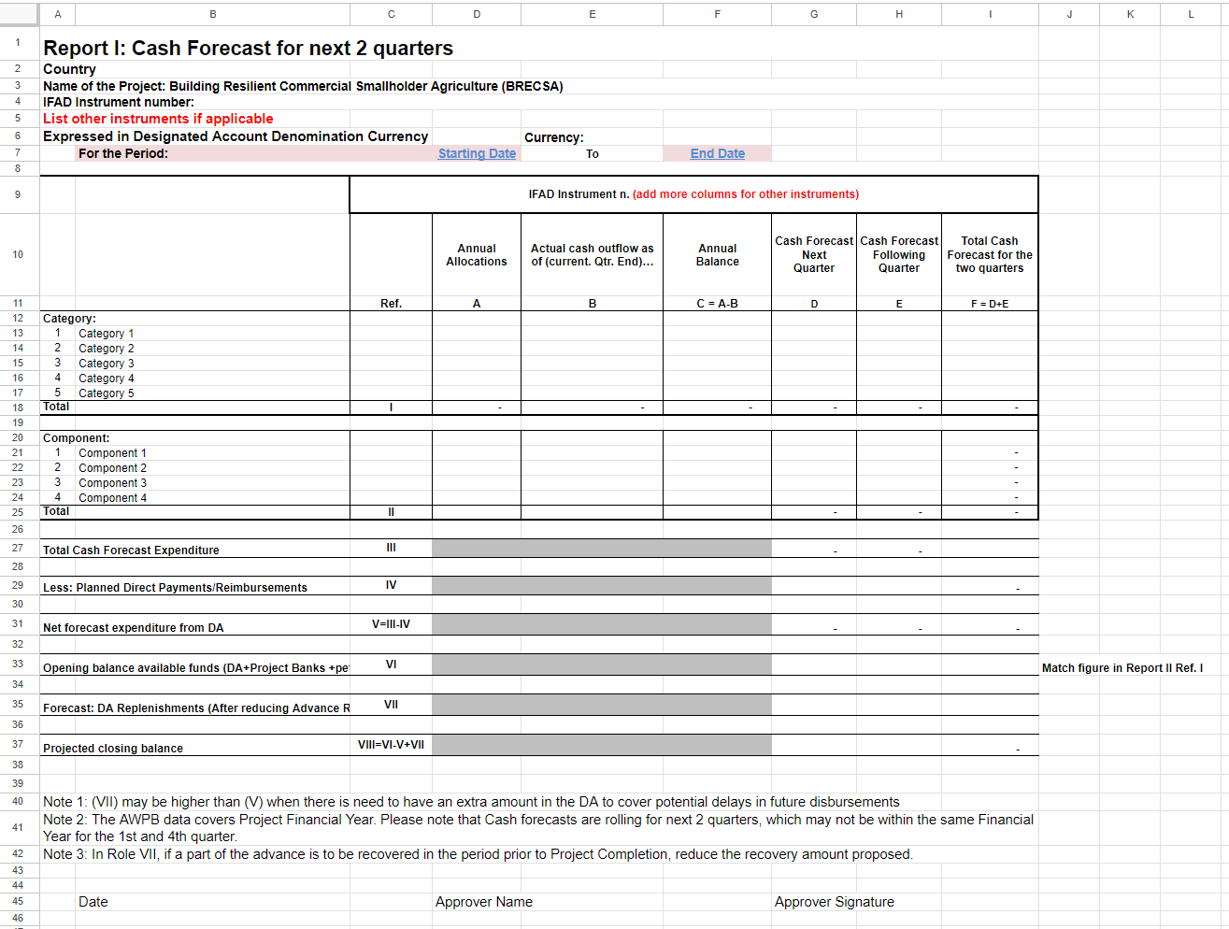

Start Date and End Date Will be manually entered and the report should be generated

Annexure Sources and Uses of Funds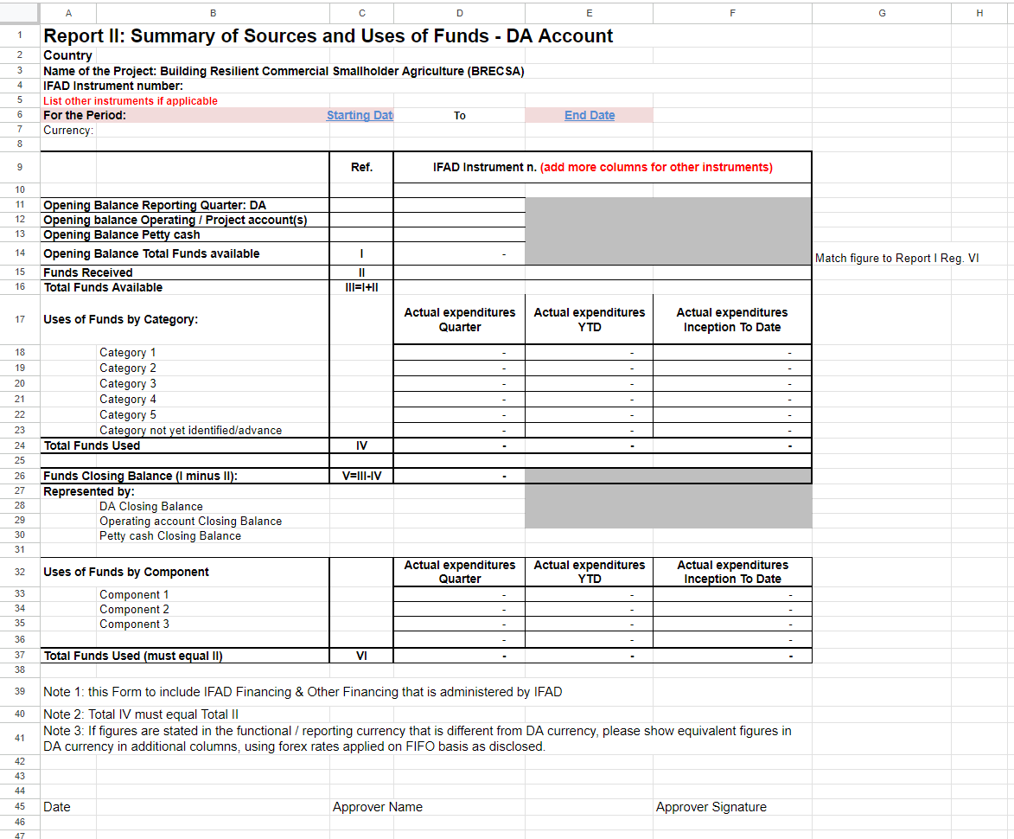

All Opening Balances and “Start Date” and “End Date” filed will be manual rest will be generated automatically.

Annexure Variance Analysis Quarter

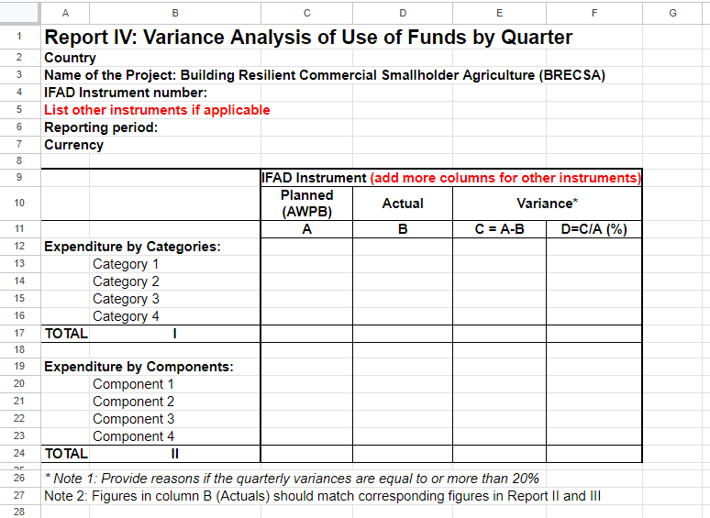

Select Quarter and the report should be auto generated

Annexure Variance Analysis FY

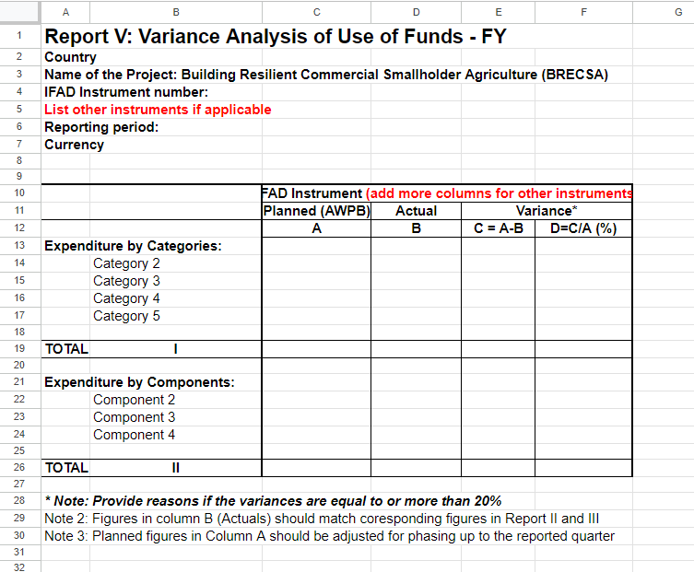

Select Project Year (PY) and the report should be auto generated

Annexure Variance Analysis Cumulative.

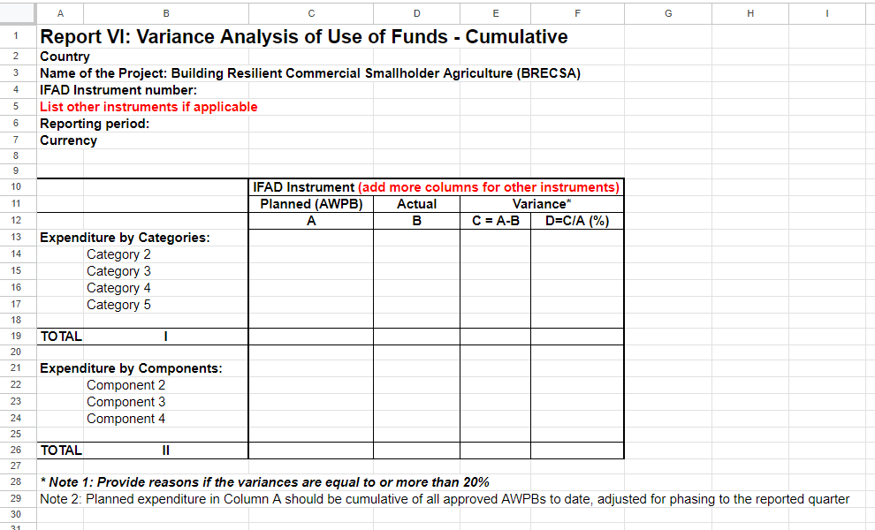

Start Date and End Date Will be manually entered and the report should be generated

Annexure Project Goal

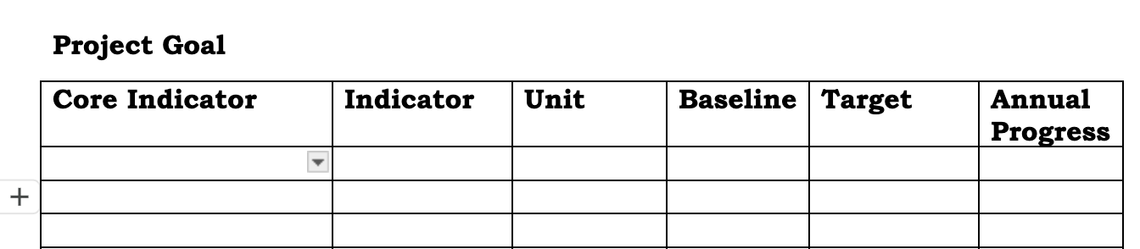

Annexure Project Objective format

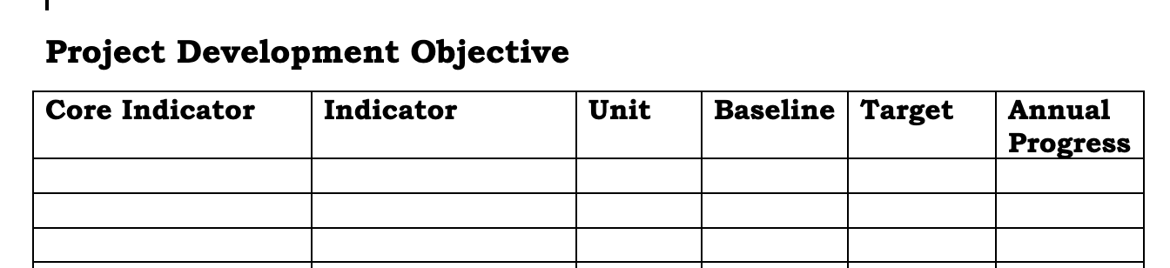

Annexure. Project Outreach format

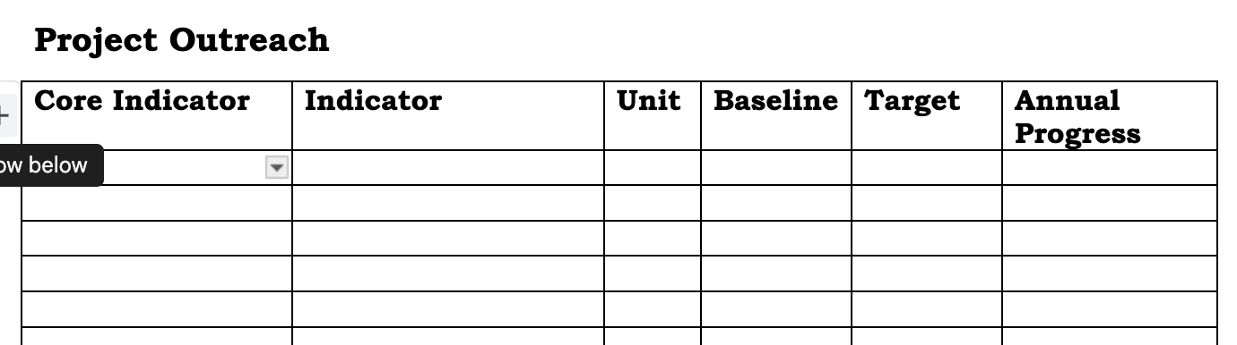

Annexure Project Outcome Format.

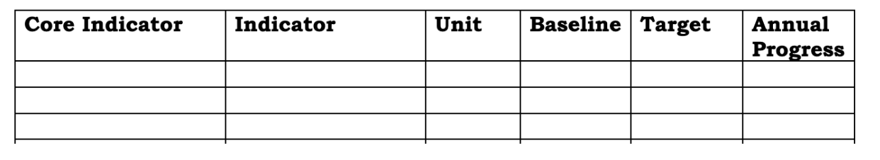

Annexure Project Output Format

